Transaction Log
The Transaction Log is where all successful payment transaction posted to your forum can be viewed. This log is the actual history of transactions posted to your forum by the payment processors. These transactions are comprised of successful charges and reversals.

This log offers several search options that enable you to narrow down searches to specific criteria.
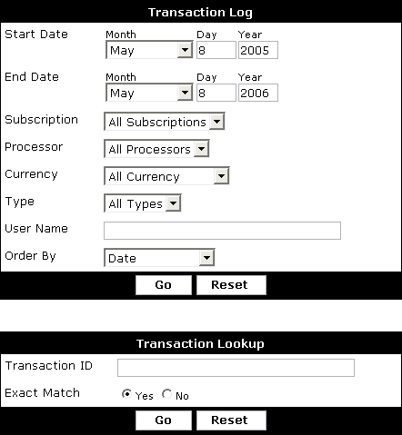
Start Date - Date to limit the oldest transactions to.

End Date - Date to limit the newest transaction to.

Subscription - Include transactions that pertain to all subscriptions or limit transactions to thost that pertain to a specific subscription.

Processor - Include transactions that pertain to all payment processors or limit transactions to those that pertain to a specific payment processor.

Currency - Include transactions that pertain to all currencies or limit transactions to those that pertain to a specific currency.

Type - Include failure, charged and reversed transactions or limit to either one.
Note:
Failed transactions are those that could not be matched up with a subscription. This generally happens when there is a misconfiguration. Click on Failure when viewing these transactions to see raw output of what was sent by the payment processor. This information can be used by support to help you troubleshoot problems.
User Name - Include transactions that pertain to all users or limit transactions to those
that pertain to a specific user.

Order By - Control the order of the resulting log. The order can also be changed when viewing the log by clicking the column headers.
Note:
Transactions completed before vBulletin 3.6.0 Beta 1 will contain incomplete information.
From this screen you may also directly look up a transaction. The transaction lookup accepts the transaction id that pertains to the transaction performed on the payment processor side. You can often find this ID in any email that is sent you when a signup is received or in the admin center of your payment processor.

